Optional South Lake Tahoe Activities

Come early or spend an extra night Tuesday, June 14th after the conference to take
advantage of the NASS room rates and beautiful surroundings. The included links will help you plan activities for you and your family. Enjoy!

- Heavenly Village - Shopping and Dining
https://theshopsatheavenly.com/

- Heavenly - Gondola for site seeing and action activities
https://www.skiheavenly.com/

- MS Dixie - Paddle Wheel Boat Cruises
https://www.zephyrcove.com

- Kayak Rentals
https://kayaktahoe.com/

- Boat Rentals
http://skirunmarina.com/

- Parasailing
https://tahoesports.com/

- Golfing
https://www.laketahoe.com/top-10-tahoe-golf-courses

- Things to Do
https://tahoesouth.com/hike/great-hikes-in-tahoe-south/

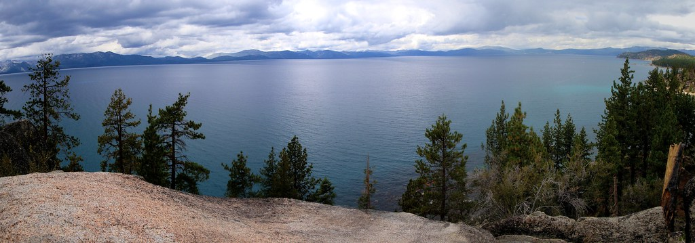

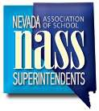

Information President Summer Stephens Vice President Dr. Jesus Jara
Secretary-Treasurer
Pam Teel
Administrative Assistant Selena Gomes
Phone: (775) 423-5184
Fax: (775) 423-2959
gomess@churchillcsd.com

District Superintendents Carson City
Richard Stokes

Churchill
Dr. Summer Stephens

Clark
Dr. Jesus Jara Douglas Keith Lewis Elko
Mike Smith Esmeralda Neil Terhune Eureka Tate Else Humboldt
Dr. Dave Jensen
Lander Russell Klein Lincoln Pam Teel Lyon
Wayne Workman
Mineral Andre Ponder Nye
Dr. Warren Shillingburg
Pershing Russell Fecht Storey Todd Hess Washoe
Dr. Kristen McNeill White Pine Adam Young

State Charter Authority
Rebecca Feiden

Page 3

